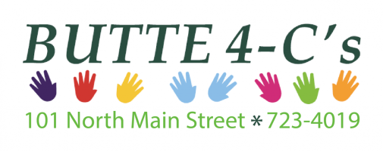

JOB DESCRIPTION
Zero to Five Project Manager
40 hours/week

ACCOUNTABLE TO:

The Executive Director. Job performance evaluation will occur following a twelve month probationary period and on an annual basis thereafter.

POSITION RESPONSIBILITIES:

- The Zero to Five Program manager will be responsible for working with the local Zero to Five Collaborative to implement, maintain, track and evaluate the programs which the Collaborative chooses to fund.

- Works closely with the Zero to Five Collaboration Coordinator to help the collaborative choose programs and make decisions about ongoing funding.

- Implement the programs with any appropriate community partners and then help to implement data-driven evaluation methods of the programs and do ongoing work needed to ensure success.

- Some of the programs will be housed at the Butte 4-C’s and will be the primary responsibility of the Program Manager. Other programs will be run by other community members or organizations and may require support from the Program Manager.

- The Program Manager will work to support the ongoing programs of the Butte Community Council as needed, ex. Kindergarten Screenings and Backpack Program and the Hospital Backpack Program.

- The Program Manager will report progress to the Collaborative at monthly meetings.

- Work closely with the Zero to Five Statewide Office to assist in implementing Statewide efforts and attain assistance with local programing as needed.

- Attends regular staff meetings, program meetings, Collaborative meetings, workgroup meetings, Statewide Office meetings and attend relevant trainings as available.

- Demonstrates ability to work as part of a team.

- Demonstrates ability to work independently.

- Consistently follows agency and contract policies and procedures.

- Performs other duties as assigned in a timely manner.

- Available to provide transportation for self as needed for local and Statewide meetings, with compensation for mileage.

SPECIFICATION:

- Bachelor’s Degree preferred. Degree can be in any field but early childhood, human services, social work or public health are preferred.

EXPERIENCE:

- Knowledge of cultural differences and knowledge regarding issues impacting low income families.

- Must have excellent communication and intrapersonal skills both verbally and in writing.

- Comprehensive knowledge of basic office computer programs, Microsoft Suite, email, Zoom, etc..

- Experience with data analysis would be beneficial.

- Early childhood systems knowledge.

DESIRABLE PERSONAL CHARACTERISTICS:

- Willingness to work with many partners and bring people together to solve problems.

- Demonstrates maturity and experience in successfully working with diverse groups.

- Demonstrates adaptability and willingness to learn.

- Solution oriented problem solver.

GENERAL:
• In-town and out-of-town travel to include over-night travel may be required to perform the responsibilities of this position. The employee is to provide a mode of transportation for this travel. Some travel may be required during inclement weather. Mileage reimbursement is provided.

PHYSICAL DEMANDS:
• The physical demands described here are representative of those that must be met by an employee to successfully perform the essential functions of the job. Reasonable accommodations may be made to enable individuals with disabilities to perform the essential functions.
- Must be able to lift 50lbs.

The noise level in this environment is quiet to loud depending upon the activity in the particular part of the day.

