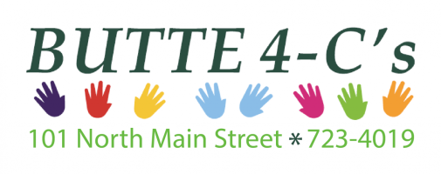

JOB DESCRIPTION
Zero to Five Program Assistant
20 hours/week

ACCOUNTABLE TO:

The Executive Director and Local Collaboration Coordinator. Job performance evaluation will occur following a twelve-month probationary period and on an annual basis thereafter.

POSITION RESPONSIBILITIES:

- Works to promote Zero to Five efforts in the community through outreach, social media, and other outlets.

- Run meetings for the Collaborative and work groups as needed.

- The Program Assistant will maintain relationships with key community partners and create a welcoming, inclusive environment for collaborative members.

- Works closely with the Local Collaboration Coordinator – Project Manager (Co-LCC-PM) to help the collaborative choose programs and make decisions about ongoing funding.

- The Program Assistant will work to support the ongoing programs of the Butte Community Council as needed, ex. Kindergarten Backpack Program and the Hospital Backpack Program.

- The Program Assistant will help create connections with partners in the community to foster collaboration and effective program implementation. For example, attending regular community meetings.

- Help the Collaborative to organize efforts, implement, the Collaborative Charter and remain adaptable to changing local needs.

- Work closely with the Zero to Five Statewide Office to assist in implementing Statewide efforts and attain assistance with local programing as needed.

- Attends regular staff meetings, program meetings, Collaborative meetings, workgroup meetings, Statewide Office meetings and attend relevant trainings as available.

- Demonstrates ability to work as part of a team and independently.

- Consistently follows agency and contract policies and procedures.

- Performs other duties as assigned in a timely manner.

- Available to provide transportation for self as needed for local and Statewide meetings, with compensation for mileage.

EXPERIENCE:

- Knowledge of cultural differences and knowledge regarding issues impacting low-income families.

- Must have excellent communication and intrapersonal skills both verbally and in writing.

- Comprehensive knowledge of basic office computer programs, Microsoft Suite, email, Zoom, etc.

- Experience with data analysis would be beneficial.

- Early childhood systems knowledge.

DESIRABLE PERSONAL CHARACTERISTICS:

- Willingness to work with many partners and bring people together to solve problems.

- Demonstrates maturity and experience in successfully working with diverse groups.

- Demonstrates adaptability and willingness to learn.

- Solution oriented problem solver.

GENERAL:
• In-town and out-of-town travel to include over-night travel may be required to perform the responsibilities of this position. The employee is to provide a mode of transportation for this travel. Some travel may be required during inclement weather. Mileage reimbursement is provided.

PHYSICAL DEMANDS:
• The physical demands described here are representative of those that must be met by an employee to successfully perform the essential functions of the job. Reasonable accommodations may be made to enable individuals with disabilities to perform the essential functions.
- Must be able to lift 50lbs.

The noise level in this environment is quiet to loud depending upon the activity in the particular part of the day.

Updated 6/16/2022

Employee Signature ______________________________________ Date ____________

Executive Director Signature _______________________________ Date____________

